**Continue and Break Keyword:**

We can use **continue** and **break** statements within loops to control the flow of execution.

**Continue:**

* + The **continue** statement is used to skip the rest of the code inside a loop and move to the next iteration.
  + It is typically used to bypass certain iterations based on a specific condition.

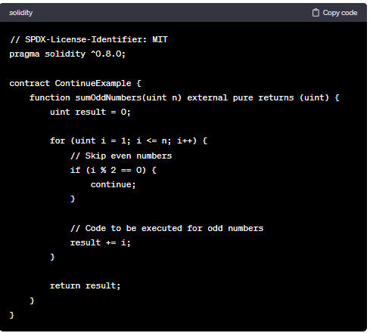

**Break:**

* + The **break** statement is used to exit the loop prematurely, even if the loop condition is still true.
  + It is typically used when a specific condition is met, and you want to terminate the loop immediately.

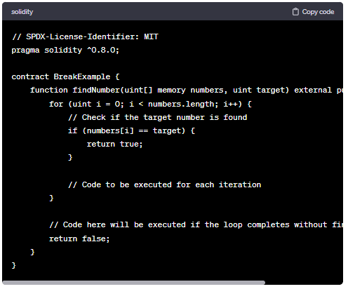

Both **continue** and **break** statements are useful for controlling the flow of execution within loops and customizing the behavior based on specific conditions.

**Code:**

//SPDX-License-Identifier: GPL-3.0

pragma solidity ^0.8.0;

contract Continue_break{

    function loop() public pure returns(uint) {

        uint count=0;

        for(uint i=0; i<10; i=i+2){

            if(i==6){

                break;

                //continue;

            }

            count = count+5;

        }

        return count;

    }

}

**For Break (Output):**

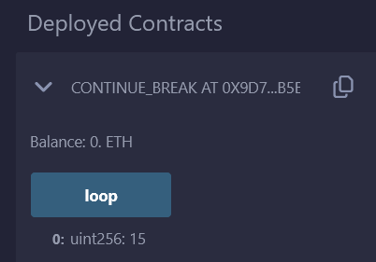

**For Continue (Output):**

